CPS/ATM Introduction
This chapter describes the Custom Payment Service/ATM (CPS/ATM) that accommodates the special card acceptance and operating procedures for international ATM transactions. This service applies to all ATM card products.
CPS/ATM was built on the Payment Services 2000 foundation introduced in 1993. It applies to international Visa and Plus transactions that originate at an ATM (merchant category code 6011) where the card and personal identification number (PIN) are present.
CPS/ATM allows accurate settlement and improved management of the cardholder’s accounts through better matching of authorization to clearing messages, using a unique transaction identifier. In addition, CPS/ATM ensures more timely delivery of clearing records by acquirers and reduces exception item processing by improving transaction integrity and life-cycle control.
This chapter also addresses new VisaNet edits for all ATM members and processors.

Qualifications for ATM Tiers
Visa has defined two levels of international ATM service that correspond to different Cash Disbursement fees. Each level provides different functionality and service to cardholders.
Issuers pay a fixed disbursement fee for each approved international Visa/Plus ATM cash disbursement. The acquirer receives a fee based on the tiered service level for which it qualifies.
To qualify for the Tier II fee, an acquirer must have completed the necessary service certifications, demonstrating business and technical qualifications. Following successful certification, qualification flags are set in the VisaNet system.
Table 1–1 displays the two levels of service functionality for Tier I and Tier II.
Table 1–1: Tiered-Service Functionality
Tier Level | Functionality
Tier I | Basic ATM service
Tier II | Enhanced functionality and service

Tier I: Basic ATM Service
A Tier I acquirer must meet the following requirements:
- Provide the basic ATM cash withdrawal service.
- Accept Visa cards and cards bearing the Plus symbol.
- Comply with the applicable Visa International Operating Regulations requirements, including but not limited to:
- Online reversal processing
- Authorization and clearing processed through the same network
- Acceptance of Visa and Plus cards encoded with an unrecognized service code
- No expiration date editing
- Use the VisaNet Integrated Payment (V.I.P.) System multicurrency service for authorization requests.
- Perform timely installation and use of the Visa and Plus Routing Tables for transaction routing.
The BASE I and BASE II technical requirements and edits are listed in Chapter 2, CPS/ATM Technical Processing.

Tier II: Enhanced Functionality and Service
A Tier II acquirer must meet Tier I requirements and all of the following additional requirements:
- Participate in Single Message System (SMS) or, for dual-message acquirers, participate in the CPS/ATM Service.
- Comply with the Visa international acquirer quality service standards.
- Participate in the Card Verification Value (CVV) Service.
- Comply with customer account selection standards.
The BASE I and BASE II technical qualifications and edits are listed in Chapter 2, CPS/ATM Technical Processing.

Compliance in Years 2003 and 2004
Participation in the SMS or CPS/ATM and compliance with Tier II requirements is mandatory for ATM acquirers effective with the October 2003 VisaNet business enhancements (CPD 4 October 2003). Acquirers that meet both the business and technical qualifications will receive Tier II fees, as described in the Visa International Operating Regulations.
SMS processing is already mandated for all ATM acquirers in the United States (U.S.) region and for all new ATM acquirers in all regions. The 2003 ATM Initiative mandates that all existing ATM acquirers must be certified for SMS or CPS/ATM processing by CPD 4 October 2003 and meet Tier II requirements. Effective on CPD 4 October 2003, ATM transactions that do not meet these criteria will lose all international Cash Disbursement fees. Furthermore, effective October 2004, these transactions will be assessed a minimum special ATM Handling fee of U.S. $5.00.
Effective October 2004, transactions from CPS/ATM acquirers that do not meet the Tier II requirements will be returned to the acquirer for resubmission. ATM transactions that are CPS/ATM-qualified after resubmission will receive the Cash Disbursement fee. ATM transactions that are not CPS/ATM-qualified after resubmission will be assessed a minimum U.S. $5.00 special handling fee per transaction in addition to any normal BASE II return fees. A CPS/ATM transaction submitted after the 3-calendar-day processing limit will not be returned to the acquirer but will be settled and assessed the minimum special ATM handling fee of U.S. $5.00.
Bilateral ATM Cash Disbursement fees and Visa TravelMoney ATM Cash Disbursement fees will be affected in the same manner as international ATM cash disbursements.

How CPS/ATM Works
This section provides an overview of how the CPS/ATM payment service works by following a transaction flow from authorization through clearing for dual-message processing.
In dual-message processing, the acquirer submits, and the issuer receives, separate authorization and clearing transactions.
All dual-message international ATM transactions must be authorized through the V.I.P. System and cleared through the BASE II System to qualify for CPS/ATM.
As of October 2003, all international ATM transactions must qualify for CPS/ATM or be submitted using the SMS. Issuers not participating in CPS/ATM are not required to make changes to either their authorization or clearing system. Issuers will not receive any new fields relating to CPS/ATM.
CPS/ATM certification is currently available for dual-message Visa/Plus international ATM acquirers and issuers.
Figure 1–1 depicts the flows for dual-message members.
Figure 1–1: CPS/ATM Flow: Dual-Message Processing
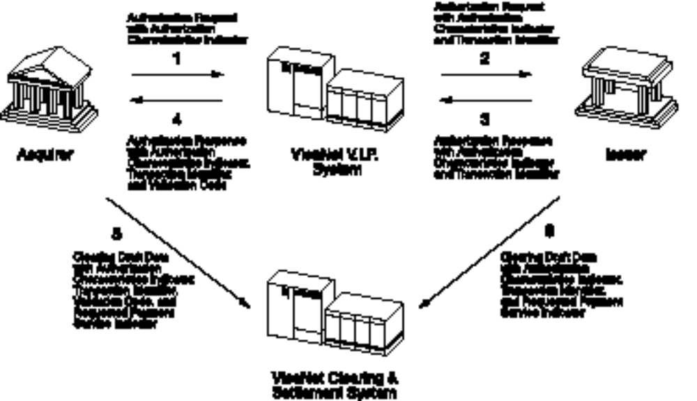
The following steps describe the CPS/ATM transactions flow for participating acquirers and issuers, shown in Figure 1–1.
- The acquirer submits an authorization request with an Authorization Characteristics Indicator (ACI) to indicate that this is a Custom Payment Service transaction.
- V.I.P. ensures that the transaction meets the criteria and evaluates the characteristics of the request, then replaces the value in the ACI to reflect the authorization characteristics of the transaction.
A unique transaction identifier is generated and is passed with the ACI to the issuer.
- The issuer approves the transaction, sends the transaction back to the V.I.P. System with the authorization response code, and optionally returns the ACI and the transaction identifier.
- V.I.P. generates a validation code based on key authorization fields. The validation code is returned with the authorization response code, the ACI, and the transaction identifier to the acquirer.
- The acquirer submits a Draft Data clearing transaction to BASE II with a Requested Payment Service indicator, which specifies CPS/ATM. The clearing transaction must also contain the ACI, transaction identifier, and validation code received from V.I.P. with the authorization response.
- By regenerating the validation code, BASE II validates that the key authorization fields contained in the Draft Data clearing transaction match those sent in the authorization request. Edits are applied to ensure that the transaction qualifies for the CPS/ATM Service.
The transaction is then forwarded to the issuer with the ACI, transaction identifier, and Requested Payment Service indicator.
The issuer uses the transaction identifier to match the clearing transaction to the authorization.
In summary, V.I.P. examines CPS authorization requests and BASE II examines CPS clearing records from acquirers to ensure that CPS/ATM requirements are met.
- If the CPS/ATM requirements are met in V.I.P., the system changes the ACI in Field 62.1—Authorization Characteristics Indicator to a value of E to reflect the successful evaluation. (For qualified CPS/ATM transaction processing, see Table 1–2.)
V.I.P. then inserts its generated transaction identifier in Field 62.2—Transaction Identifier in the message, and forwards it to the issuer or to stand-in processing (STIP) for an approval or decline decision as follows:
- If the issuer approves the request, V.I.P. ensures that the ACI is present in the response for the acquirer, and it adds the validation code in Field 62.3—Validation Code.
- If the issuer does not approve the request, V.I.P. returns the transaction with an ACI value of N in field 62.1 to the acquirer, and the Downgrade Reason Code NA is added to field 62.3.
- If the CPS/ATM requirements are not met in V.I.P., the system changes the ACI in field 62.1 to a value of N to indicate a
non-qualified transaction and indicates a code for the downgrade reason in field 62.3. V.I.P. forwards the message to the issuer for the approval or decline decision. (For downgrade reason codes, see Table 1–3.)
- If the CPS/ATM requirements are met in BASE II, the authorization message is considered eligible for CPS/ATM and the transaction will have CPS/ATM Cash Disbursement fees applied.
- If the request fails to meet the CPS/ATM program edit requirements, and BASE II has found no reason to reject the message, BASE II forwards the downgrade reason code in TC 04, TCR 9, positions 104–106 and the transaction will have
non-CPS/ATM Cash Disbursement fees applied.

Authorization
All Visa/Plus international ATM transactions must be processed through the V.I.P. System. CPS/ATM requests must include a valid ACI value of Y.
Once the message is received by V.I.P. and the contents of the authorization or financial request are examined and validated, V.I.P. replaces the ACI with an appropriate value.
For qualified CPS/ATM transactions, Table 1–2 shows the ACI value submitted by the acquirer, CPS/ATM authorization criteria, the validation result, and the V.I.P. value returned to the acquirer.
Table 1–2: Qualified CPS/ATM Transaction Processing
ACI Value Submitted by Acquirer | Authorization Criteria | Validation Result | V.I.P. Value Returned to Acquirer in Field 62.1 | Downgrade Reason Code in Field 62.3
Y | - Valid account number in track data  - Card authentication through CVV  - Expiration date is in track data  - Valid country code  - Valid MCC (6011)  - Acquirer is a participant in multicurrency (non-U.S. only)  - Issuer-approved transaction  - Acquirer is a participant in CPS/ATM  - Valid Visa or Plus card  - Account number matches track 2 data  - Expiration date matches track data  - Valid account number  - MCC present  - POS entry mode contains a value of 90 (magnetic stripe read and exact content of track 2 included [CVV check is possible]) or 05 (integrated circuit card read; track data [including CVV] reliable)  - ATM owner and location data submitted in the authorization request | Card present with valid data; all authorization criteria are met | E | n/a
n/a = not applicable
For non-qualified CPS/ATM transactions, Table 1–3 shows the ACI value submitted by the acquirer, CPS/ATM authorization criteria, the validation result, the V.I.P. value returned to the acquirer, and the downgrade reason codes for invalid authorization criteria.
Table 1–3: Non-Qualified CPS/ATM Transaction Processing
ACI Value Submitted by Acquirer | Authorization Criteria | Validation Result | V.I.P. Value Returned to Acquirer in Field 62.1 | Downgrade Reason Code in Field 62.3
Y | - Valid account number in track data | Transaction downgraded; one or more of the authorization criteria not met | N | AN
Y | - Card authentication through Card Verification Value (CVV) |  | N | CV
Y | - Expiration date is in track data |  | N | ED
Y | - Valid country code |  | N | IC
Y | - Valid MCC (6011) |  | N | IM
Y | - Acquirer is a participant in multicurrency (non-U.S. only) |  | N | MC
Y | - Issuer-approved transaction |  | N | NA
Y | - Acquirer is a participant in CPS/ATM |  | N | NT
Y | - Valid Visa or Plus card |  | N | NV
Y | - Account number matches track 2 data |  | N | TA
Y | - Expiration date matches track data |  | N | TD
Y | - Valid account number |  | N | 02
Y | - MCC present |  | N | 18
Y | - POS entry mode contains a value of 90 (magnetic stripe read and exact content of track 2 included [CVV check is possible]) or 05 (integrated circuit card read; track data [including CVV] reliable) |  | N | 22
Y | - ATM owner and location data submitted in the authorization request |  | N | 42
Not = Y | Field 62 is not forwarded to issuer or returned to acquirer | ACI invalid | Omitted | n/a
n/a = not applicable

Clearing
All Visa/Plus international ATM transactions using dual-message processing must be cleared through the BASE II System. Each CPS/ATM clearing message must include the transaction identifier, the ACI value of E, and the validation code from the authorization response. All authorization requests must have been approved and the clearing message submitted within three (3) calendar days from the transaction date to qualify for CPS/ATM.
Additionally, the clearing transaction must include the acquirer's request for the CPS/ATM fee through the use of the Requested Payment Service indicator. The Requested Payment Service indicator value of 9 indicates that the transaction complies with the CPS/ATM authorization and clearing qualification rules.
To qualify a transaction for CPS/ATM, the validation code will be verified by VisaNet to ensure that authorization and clearing data elements are identical. A successful validation confirms that the international ATM transaction has been properly authorized.
For further information on BASE I and BASE II system edits,
see Table 2–1.

Reclassified Transactions
Transactions that do not meet the authorization-related edits for CPS/ATM will be reclassified as non-Custom Payment Service transactions. BASE II will change the ACI to a value of X, indicating that the transaction does not qualify for CPS/ATM. A BASE II Transaction Code (TC) 04 advice will be sent to notify the acquirer that the transaction was reclassified.

Delivering the Transaction to the Issuer
For the issuer participating in CPS/ATM, a Transaction Component Record (TCR) 5 will be included in Draft Data. This record includes the transaction identifier.
Issuers must be able to receive the Draft Data TCR 5 in incoming original ATM cash disbursement transactions. An issuer receiving the transaction identifier will be able to manage cardholders’ open-to-buy balances more effectively by matching the authorization and clearing records.

Exception Transaction Processing
All original CPS/ATM cash disbursement transactions will contain a transaction identifier in the BASE II Draft Data TCR 5. V.I.P. assigns a transaction identifier in all CPS/ATM transactions at the time of authorization. The transaction identifier must be retained and returned in subsequent chargebacks.
CPS/ATM edits are not applied to exception transactions.

